Minutes of the meeting held on Monday 29th November 2021

Present:
Cllr. Gill Hill (Chair)
Cllr. John Jervoise
Cllr. Simon Wills
Cllr. Bob Ives
Cllr. Will Cheyney
Tracy Crawford (Clerk)
In attendance:
B&DBC Mark Ruffell
5 local residents
Apologies:
PC Ross Holdsworth
PCSO Andy Jones
HCC Juliet Henderson
Mayor of Basingstoke Onnalee Cubitt

Apologies received as noted as above.
- Amendments to the agenda
- Motion 7 to be debated
- Item 12 to be Property and projects

Cllr Jervoise declared an interest in matters involving Herriard Estates and associated properties.

- Cllr Gill Hill welcomed Tracy Crawford as the new Clerk to HPC.

- Minutes were approved and signed as a true record of the Parish Council meeting 27th September 2021.

External reports

Police report – PCSO Andy Jones, attached as appendix 1.
PC Ross Holdsworth was unable to attend this meeting.

- Dee Haas and Emma Bedford presenting information about AONB. Map attached appendix 2.
- Dee Hass chair of CPRE and part of the group Stand are looking for support to make the North Hampshire downs an area of outstanding beauty (ANOB) connecting the area to the south downs, looking at the management of the landscape, how it might evolve, how to farm it and looking after land marks, protecting the land but lets small villages expand,
- Each ANOB needs a management plan, looks at growth building and biodiversity.

- HCC Juliet Henderson, Attached as appendix 3.

- Chair report - Cllr Hill, attached as appendix 4.
- Motion to debate AONB.
- The Councillors discussed the issue. We are in a managed landscape not natural, Businesses should allow the changes this would make it difficult to grow,
More hoops to expand farms, with farmers trying biodiversity will this add more red tape?
- It was agreed this needs more discussion and possibly a survey for the whole parish
- Motion deferred till another time to allow for more information

- Motion to adapt policies- code of conduct Standing orders- Cllr Hill.
- Standing orders are the written rules of a local council, essential to regulate proceeding’s
Motion moved by Cllr Hill, Seconded by Cllr Wills, All agreed.
- These were accepted and will be placed on the Parish Council website. They will provide increased transparency and guidance for how the council operates for current and future councilors and villagers, thereby providing support for councilors in their decisions.

Climate change sub-committee update- Cllr Wills.
- The council held an open Climate Change meeting on the 19th October to explore what can be done as a village and as individuals to help address the climate emergency. There was good attendance, with over 10 villagers attending, aged from under 16 to over 60 and time was spent discussing ideas in 5 potential areas of; Transport, Energy, Waste, Food and Nature. The group generated over 20 ideas, from a simple as tree planting to as complex as setting up our own community energy company. The ideas included a segregated central recycling facility for items not currently recycled by B&DBC, local food waste collection for the AD plant, a website for energy efficiency advice and to allow sharing of unwanted goods, a bulk buying “club” for dry goods and cleaning products and maybe oil and ultimately bio-oil, a feasibility study for renewable energy on community buildings, a bug hotel built on The Green involving local children and many others. Some of these ideas are now being developed by members of the group and once more detail is available the group will reconvene to progress things further. Other villagers are more than welcome to attend the next meeting.
We have also submitted a National Lottery grant application for one of the ideas, the website, that we are calling the Herriard Climate Change Hub (HCCH). This is intended to inform, support and facilitate local climate positive actions. If funded, it will be internet based, open to all and should host a lifestyle CO2 calculator and reduction tips, an energy efficiency calculator and tips, a local swap “marketplace” and potential be available to support the bulk buying “club” and other future initiatives. It is intended to host it within the current Herriard Parish Council website. If funded we would launch it in the new year with a community event, including guest speakers and activities, likely at The Green, including building the bug hotel previously mentioned.
It is still early in the lottery grant process but we would hope to hear within approximately 12 weeks, so mid-February 2022.

- Proposal to hold a budget meeting - Cllr Hill.
Cllr Hill proposed a Budget meeting to discuss CIL money, Langlies Mead reline of the road and a paid Clark position.
Agreed this will be a closed meeting on the 9th December at 18.30

- Proposal to produce a costings for a shelter at the Green- Cllr Hill.
- The need for a shelter was discussed. To protect from rain and sun, suggestions of an open shelter with a sail was given from meeting attendees, and a request to ask Basingstoke and dean if they have any problems with youths in their public areas.
Agreed to look at alternatives and to look at costing’s.

- Property and Projects report - Cllr Jervoise.
- Langlies Mead housing - New designs have been drawn, 1 more private house may be needed however the PC will gain financially as rental income from one house will come to the parish Council via the village charity. Hopefully more information will be ready the 1st quarter of next year.
- The current Little Crickets Manager is retiring at Christmas and unfortunately it will close at Christmas. However out of 9 candidates 1 person has been chosen and will hopefully be able to open in the spring with relevant requirements in place
- The Diocese have now approved the planning application to the Church, Basingstoke and dean still to approve – under review.

- Planning Applications - Cllr Wills.

- 21/00744/RET Change of use at Scratchface Lane from Agri/equestrian to dog training - going to committee 2022.

- 21/01491/PIP Permission in principle single dwelling Back Lane – going to committee 8th December.

- 20/03130/FUL Motorway service temporary construction road – is not determined.

- 21/02618/LBC Replacement windows Scratchface Lane - registered, no objections but can not be approved at present as conversations are continuing with the planning officer.

- 21/03156/LBC Replacement conservation roof lights Home Farm Cottage – no objections but not yet determined.

- Bio power granted.

- Herriard green update- Cllr Ives.

- The tire walk in the small children’s area has been repaired. The wood is being monitored at present, this is done visually weekly with monthly and annually reviews carried out by external companies.
- The fencing around the area will need replacing soon.
- The Hyde farm pond will need a spring project to clear it, proposed for February.

- Approve Parish Council Financial summery- Cllr Hill.

- Attached as appendix 5.

Community Liaison - Cllr Cheyney.

Gemma Hounsell declared that the WI will close at the end of March. With only 6 members attending its been decided to close the group.

Members are looking for an alternative group in Shalden to attend.
- Hyde farm have now opened a produce shop, which is open at weekends. Selling eggs, flour, bread and other items. Looking to expand soon with Bee hives soon coming to the farm for local honey. Follow signs to the Egg shed on back lane.
- An Estate Farms tour in spring is being organized. A chance to visit our local farms, learn what they do and how they are doing it. More information to follow.
- We are looking for ways to introduce ourselves to our new village residents, if you are attending a village event please invite your neighbours.

Open Forum -
- The 40mph roundels are now painted.
- Rod Bolt is looking into the signage issue on the A339 but unsure what the issue is.
- It was agreed that the smiley face speed watch signs would be good for the village but they are very expensive and permission would need to be needed.
- 2 dashcams are available for residents to borrow for an agreed time, contact the Clerk if interested in borrowing.
- It was discussed that more information be put on the village site about what the parish council are doing.
- Rod asked if there was a report to the background noise survey carried out with regards to motorbike noise, this shall be investigated.

18. Confirm date of budget meeting – 9th December 18.30.

The date for the next meeting: Monday 17th March 2022 RBL Hall at 7.30pm.

Meeting closed at 21.30.

Appendix 1: Police report, PCSO Andy Jones, for meeting held on 27th September 2021

Police Newsletter for the Upton Grey & Candover`s July – Sept 21

Wildlife related incident
On the 3rd of October a report of dog having bitten one of the Farmers Sheep in the Ellisfield area. Police have attended and spoken with the person who was responsible for the dog at the time. The dog owner was under the impression that the sheep was cornered but does not believe that the dog actually bit the sheep in question.
Vet has confirmed the injury and it is being considered to be dealt with by an out of court disposal and a Dog Behavior Contract.
Two theft from vehicles reported
On the 27th Sept a Nissan Pick-up has had items stolen from it, namely a Stihl blower, Stihl Hedge Cutter & Stihl multi-tool. Cliddesden.
On the 7th October it has been reported to the Police that a catalytic converter was stolen from a BMW M5 in Upton Grey. The between times are lengthy and this could of happened between 28th Feb 2021 to the reporting date.
Theft
Between the 1st & 16th October a Public House in Herriard has reported that its cooking oil has been stolen. This is a reasonably common occurrence in general at all premises that serve food. The oil itself is of reasonably low value but there is obviously a bigger market where it is being processed and turned into a bio-fuel.
Whilst CCTV has captured images of offenders there are no lines of enquiry at this time.
Suspicious incidents
There have been six incidents reported in the last 45 days.
Criminal Damage
There have been three reports of Criminal Damage incidents.
26th Sept a car was damaged whilst parked in a remote layby in the after being keyed by unknown offenders in the area of Herriard Weston rd.
23rd – 25th Oct damage was caused to fields by persons Hare Coursing in the Moundsmere area.
Between the 16th of Sept & the 28th Sept a (SID) Speed Watch Indicator has been damaged, the damage appears to have been caused by a projectile having been fired from a Catapult.
Impairment
29th November Police were in attendance on the A339 just passed the Lasham turning in relation to a Road Traffic Incident. Partial road closure implemented to control traffic. Passing motorist drove through this at speed, they were stopped by Police and blew in excess of the drink drive limit. Person arrested and transported to Basingstoke Police Stn.
Burglaries
Between the 16th & 18th October a Dwelling property that was being built in the area of Herriard has been accessed and damage caused as a result. This was an unoccupied property at the time.
In the early hours of the 25th October a shed has been gained and damage caused as a result. Items stolen from within consisted of two bicycles and a paddleboard.
Early hrs of the 26th October access was gained to a non-dwelling property in the area of Tunworth. A large number of petrol powered tools have been stolen including a Bronze colored deer statue.

On the 26th October between 0730 & 0800 hrs a cabin in the Parish of Upton Grey was accessed causing damage in the process and removing hand tools from within.
Dummer in recent days has seen an influx of incidents.
A vehicle was stolen from outside of an address, the owner used this for his tree surgeon business had items in a safe box which was secured in the vehicle itself.
Access was gained to an insecure outbuilding in Dummer on a farm, several Stihl items and other misc. tool were also stolen.
A vehicle that was seen in suspicious circumstances parked up in a carpark of a Public House off of the A33. On attending the vehicle 3 males were within all laying horizontal and a Lurcher type dog within. It was strongly believed that occupants were out to go coursing obviously forgetting the vehicle had not been taxed or MOT for the past 2 years and insurance was also not held.
On the 19th of November Basingstoke and Winchester Rural Police ran an Operation targeting people and vehicles believed to be out of place.
1 vehicle was seized on the A33 Dummer after not having Tax & Insurance. Having 4 people sat in the front of the van with only 3 seats didn’t go down well either.
Another vehicle was followed into a parking area which we noticed also had a lack of tax and insurance, unfortunately the driver disappeared into a nearby shop and Police were unable to locate him. But the driver chose to abandon the vehicle as it remained there for most of the evening.

Appendix 2

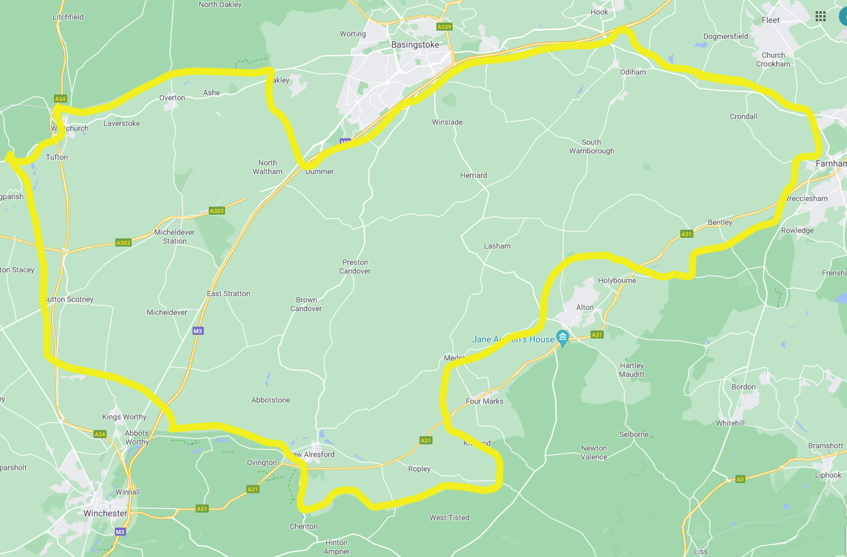

Appendix 3
Report for the PC meeting 29.11.21 by Juliet Henderson HCC

I was delighted to hear from Highways and confirmed by you, that the roundels are now painted.

The points I was going to raise related to:

- Rural Crime roundtable with Police and Crime commissioner has been moved to 28th February at 6pm at Cliddesden Village hall. The change in date is due to the fact that the P&CC, Donna Jones has arranged for the Hampshire Lead on Rural Crime, Inspector Korine Bishop, to attend the meeting.
- 20mph in villages and Residential Areas; I am pleased to confirm that Hampshire is now considering 20mph for villages and Residential areas. The Police and Crime Commissioner is also supportive. The Select Committee for Environment Transport and Economy is setting up a working group to look at this Policy. Cllr Stephen Philpott is chairing the Select Committee, which will examine introducing 20mph limits on a countywide basis. Should residents and the PC Like to write in the details are below;
Philpott, Cllr Stephen.Philpott@hants.gov.uk
Deputy Leader HCC Rob Humby who has announced the proposal to examine 20 mph limits;
Humby, Cllr R Rob.Humby@hants.gov.uk
Cllr Russell Oppenheimer who is the Cabinet Member responsible for Roads.
Oppenheimer, Cllr R Russell.Oppenheimer@hants.gov.uk
- With Carbon emissions being reduced by approx. 25% I would also suggest emailing Cllr Jan Warwick, Cabinet member for environment.Warwick, Cllr J Jan.Warwick@hants.gov.uk

Some key points I think are worth making;

- Promote Active lives- people need to feel safe to walk and cycle and parents in order to walk children to school!
- Policing by consent- people drive more safely in 20mph zones and are more aware
- Cut Carbon emissions by 26%when speed is reduced from 30mph to 20mph
- This policy is popular with people!
As Your County Councillor, I believe this policy is crucial for residents in my division and the County and I will do my utmost for residents to achieve this.

Finally, the Hampshire Countryside team can train volunteers to clear and maintain Footpaths and I can contribute towards costs and equipment via my Councillor Grant if this is of interest.

With kind regards
Juliet

Appendix 4
Chair report for the meeting 29th November 2021
New Clerk
At our last meeting I announced that our Clerk, Jun Thrussell was standing down. I am now very pleased to welcome our new Clerk, Tracy Crawford. This is an important role for the Parish Council and we rely on a good administrator to help us in our everyday work and in dealing with financial matters. The role of Clerk includes the title of Proper Officer and Responsible Financial Officer. I am very grateful to Jun who has offered her time to help Tracy understand the responsibilities of the Clerk and handover the reins. In addition, the Council have agreed to offer Tracy external training opportunities. All the Councillors were very happy to appoint Tracy and we welcome her to the team. This role is currently voluntary as it has historically always been, but this may become a paid job, which I believe will help in the retention of the Parish Clerk.
Parish Meeting Agendas
As a newly appointed Chair for HPC I am seeking greater discussion and more open decision making at PC meetings rather than simply updates on areas of responsibility. This is in order to facilitate more openness and transparency in our business proposals.
The agenda going forward will include updates on Councillor responsibilities or what’s been going on, which should be kept brief; but it will also contain items that are up for debate and will be voted on or considered for further discussion at a later date. I invite all Councillors to be proactive in bringing forward items for the agenda that require discussion leading to formal PC decisions in the public forum.
The main business will now be following the Chair’s report. I envisage there may be visitors and experts at these meetings who will help us in coming to a decision and will give the wider community more information on certain subjects and the opportunity to comment.
Code of Conduct
Since the last meeting, Councillors agreed to the adoption of the draft Code of Conduct, a mandatory policy for Local Councils, that was recently sent by Basingstoke and Deane to all Councils setting out the behaviour expected of Councillors and which applies as soon as councillors sign their declaration of acceptance. We will be voting to adopt the Code of Conduct formally at this meeting and this document will be put on the website under Policies and Procedures.
Standing Orders
We are advised by organisations such as NALC (National Association for Local Councils) to adopt standing orders to regulate the business of the council and I have adapted their model to provide HPC with guidelines for all aspects in the running of the Council. Going forward I see them as vital in ensuring correct governance and protocols. I was not aware of standing orders until a NALC officer suggested we adopt them and I have since made use of them as a new Chair. They are also very useful for the Clerk. We will also be voting to adopt standing orders which will then be on the website.
Policies and Regulations
HPC currently has Data Protection/GDPR procedures which will be reviewed at the next PC meeting. The Council does not have to have a Data Protection Officer. Going forward, I want the Council to adopt written policies for Financial Regulations, Risk Assessment, Safeguarding, Health and Safety, Asset Register, all of which I aim to have ready for adoption at the next PC meeting..
Affordable housing
Langlies Mead is now finally moving forward thanks to the Estate taking it on. John Gareth and I met online with Jonathan Ross who showed us a revised set of drawings. More on this from John. For a small village, we are contributing to the housing need in this country and helping young people get on the housing ladder. I don’t agree with wide scale development and destruction of countryside but communities need to grow and support the need for housing. This development will provide affordable housing with environmental credentials.
AONB
Herriard sits in the proposed area for AONB status. The implications of which will be shared at this meeting and the Council will vote on whether to support this initiative, brought about due to the Swallick Garden proposal for 2500 houses.
Policing
Cllr Cheyney, Cllr Jervoise and I attended the inaugural barn meeting at Brown Candover on 6th Oct-where Chief Inspector Matthew Reeves outlined the challenges of policing in both urban and rural areas. He introduced speakers from the Neighborhood Policing and Country watch teams. There was an update on gun laws, counter terrorism (theft of ammonium nitrate from rural areas) and Country watch policing.
Key messages-
- if you see a crime being committed, report immediately via 999. Use codes Operation Galileo for hare coursing and poaching on land, Op Slid for ATV and quad bike theft, Op Rebate for other rural theft and burglaries.
-don’t approach criminals
-don’t leave guns visible in cars
-new app DISC to be launched which will offer better connectivity for landowners and farmers with the rural police team

We will publicise the next barn meeting in the magazine to reach other farmers in Herriard. I will be attending a longer meeting with Donna Jones, Police and Crime Commissioner, in February 2022 and I invite residents to share concerns with me so I can take them to the meeting.

Dashcams-
The PC has 2 dashcams that can be loaned to residents on a rota basis to assist police in traffic incidents. Residents can contact the Clerk if you wish to borrow one.

Speedwatch- locations in Herriard were assessed but the person responsible for liaising has said that they are currently waiting for HCC to deal with signage issues on the A339 and until this has been dealt with they are unable to authorise the road for Speedwatch. I assume signage refers to the 40mph roundels. We re visit this and would need to see how much response we would get for the call for volunteers which would be vital before spending quite a large sum of money.
Climate Change
We have started a subcommittee for Climate Change which I see as a positive move forward and something that will involve the wider community. My thanks to Cllr Wills for initiating this and for his hard work. A public meeting was held at RBL on 19th Oct attended by 11 people including Simon and myself. More from Cllr Wills on this. An application for lottery funding has been sent by Cllr Wills.
Cllr Henderson from HCC has informed me that grants are available for community building to combat climate change. This could be for installing energy efficient measure such as LED lighting conversion, improvements to heating systems, window replacements, solar panels. Smaller grants are also available to undertake energy performance audits prior to larger work.
Gill Hill
Chair Herriard Parish Council

Appendix 5: Financial summary - Herriard Parish Council Income and Expenditure 1/4/2021 - 24/11/2021

